Task 2

Create deployment with simple application

kubectl apply -f nginx-configmap.yaml

kubectl apply -f deployment.yaml

Get pod ip address

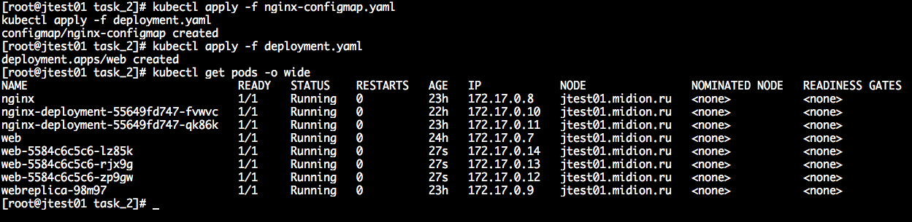

Create service (ClusterIP)

kubectl expose deployment/web --type=ClusterIP --dry-run=client -o yaml > service_template.yaml

Apply manifest

kubectl apply -f service_template.yaml

Get service CLUSTER-IP

kubectl get svc

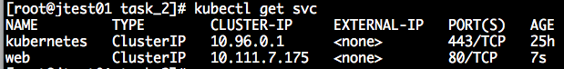

NodePort

kubectl apply -f service-nodeport.yaml

kubectl get service

